**Build end-to-end ELT pipeline using Amazon Redshift, AWS Glue, AWS Step Function & visualize using XXX**

**Participant’s Guide**

Version 1.1

*Authored by*

*Praveen Cheruvu, Director Analytics,* praveen.cheruvu@appsassociates.com

# In this lab you will create an end-to-end ELT pipeline using AWS resources to ingest and visualize [Supply Chain](https://www1.nyc.gov/site/tlc/about/tlc-trip-record-data.page) sample data. This lab guides you in the process of creating AWS resources through Cloudformation stack. As you walk through the lab you will gradually get introduced to Amazon Redshift, AWS Glue, AWS Step Function, QuickSight as the building blocks for ELT pipeline.

**Lab –Architecture Diagram:**

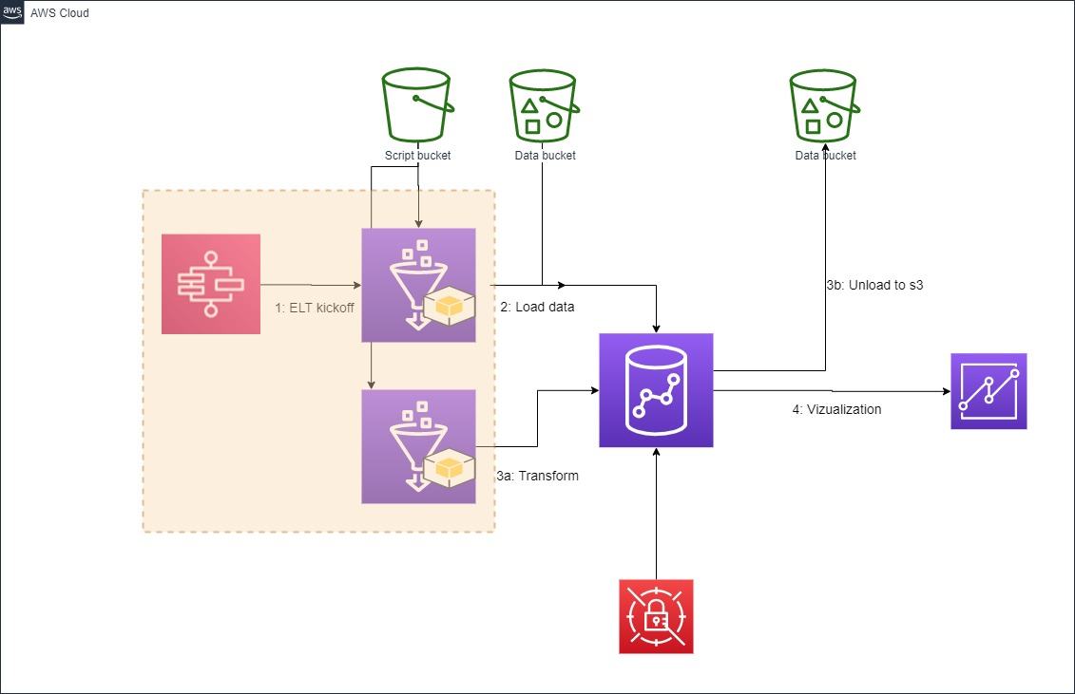

**Please use us-east-1, us-east-2 and us-west-2. Instructions may not work in other regions.**

**Cloud Formation**

To launch this Redshift cluster, Glue resources, Step function we use Cloud formation template.

After you click on the Launch Stack button below follow the screenshot instructions to avoid any S3 access errors.

* Click the below button to launch necessary AWS resources required for this lab. Please note you need to have an AWS account prior to launch these resource.

[](https://console.aws.amazon.com/cloudformation/home?#/stacks/new?stackName=SupplyChain&templateURL=https://aaredshift.s3.us-east-2.amazonaws.com/supplychain-lab/cft/launch_v1.2.yaml)

* Click **View in Designer** button.

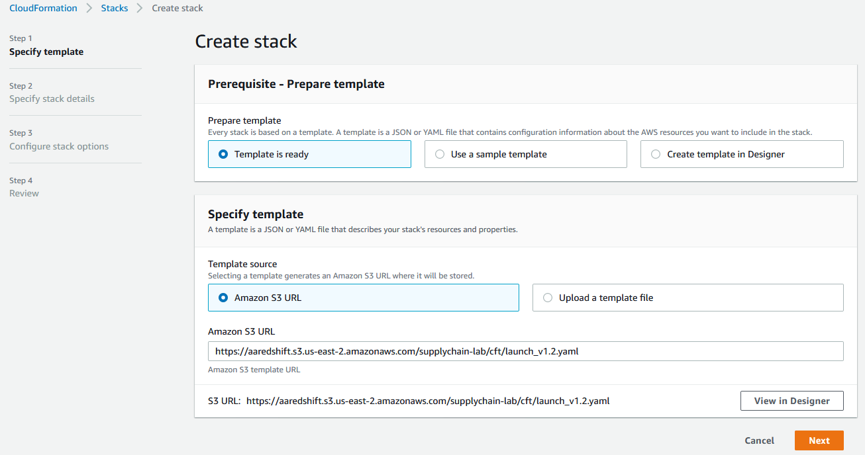

* Wait for 5 seconds to allow the architecture diagram populated. Once the diagram becomes visible click on **Validate template** button. One validated click on **Create stack** button.

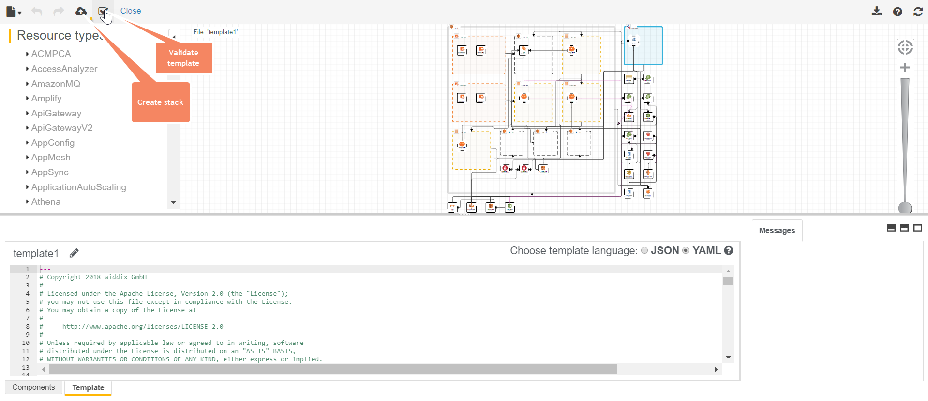

* Click Next on **Create stack** page.
* Give a name to your stack like “RedshiftLab” and hit Next.

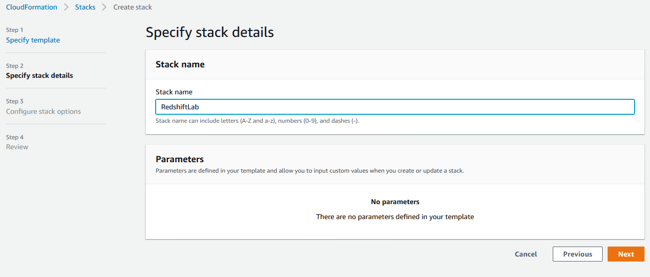

* Hit Next one more time after which you are in Review page. Scroll down to bottom, select **I acknowledge …** and hit **Create stack**.
* For the next 5 minutes monitor progress of your Cloudformation stack.

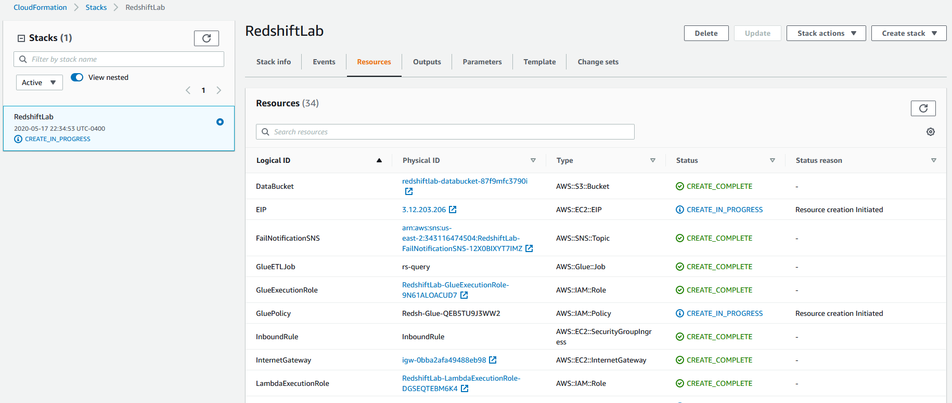

* After about 5 minutes the Stack creation completes.

# **Setting up:**

In this lab a Python Shell job is the heart of all the ELT being done in Glue. This Python scripts and other SQL scripts are required to be placed in your lab specific s3 bucket.

The very first thing you will do after logging in into your team AWS account is to navigate to S3 service.

Navigation: **Services > S3**

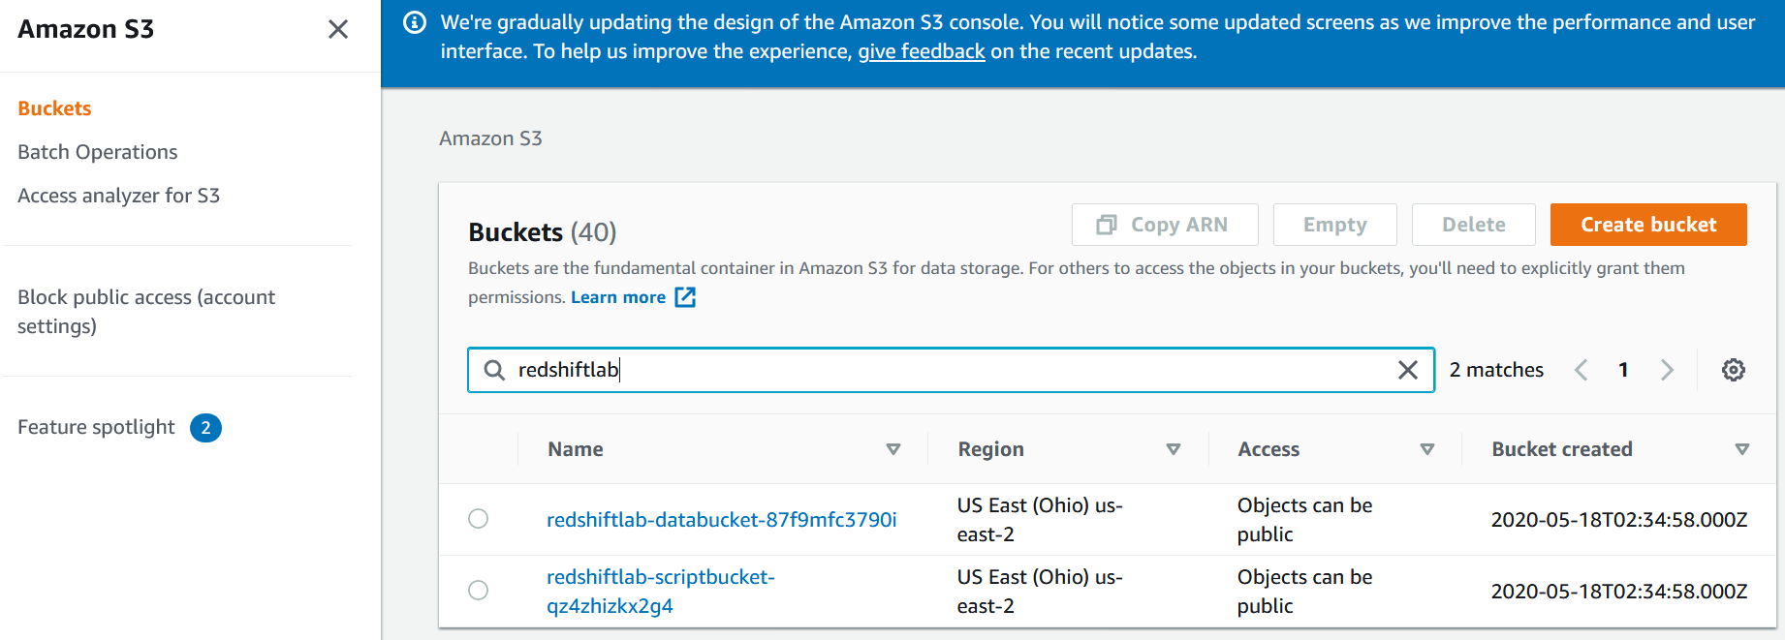

You will see 2 buckets already created for you- one is scriptbucket and another is databucket.

Next you will replace files in each of these buckets. Follow below steps.

Note: If you are not familiar working with s3 console please ask the instructor how to perform create folder, upload files etc.

* First download necessary files from below locations into your local machine.
  + python <https://github.com/praveen05ch/redshift-lab/tree/master/python>
  + sql <https://github.com/praveen05ch/redshift-lab/tree/master/sql/supplychain>
  + data <https://github.com/praveen05ch/redshift-lab/tree/master/data>
* Upload these downloaded files into your lab specific s3 bucket in proper location as shown below-
  + [python](https://github.com/saunakc/redshift-dataengineering-lab/tree/master/python) 🡪 redshiftlab**-scriptbucket**-{randomstring}/python
  + [sql](https://github.com/saunakc/redshift-dataengineering-lab/tree/master/sql) 🡪 redshiftlab**-scriptbucket**-{randomstring}/sql
  + [data](https://github.com/saunakc/redshift-dataengineering-lab/tree/master/data) 🡪 redshiftlab-databucket-{anotherrandomstring}/csv

# **Navigate to your Amazon Redshift cluster:**

Navigation: **Services > Amazon Redshift > Clusters**.

For this lab a 2 node dc2.large Redshift cluster has already been crated for you.

Review and familiarize yourself with the new Redshift console. Specifically check out the **Dashboard**, **Editor** and **Config** icons from the left pane.

Under Dashboard click on the single cluster

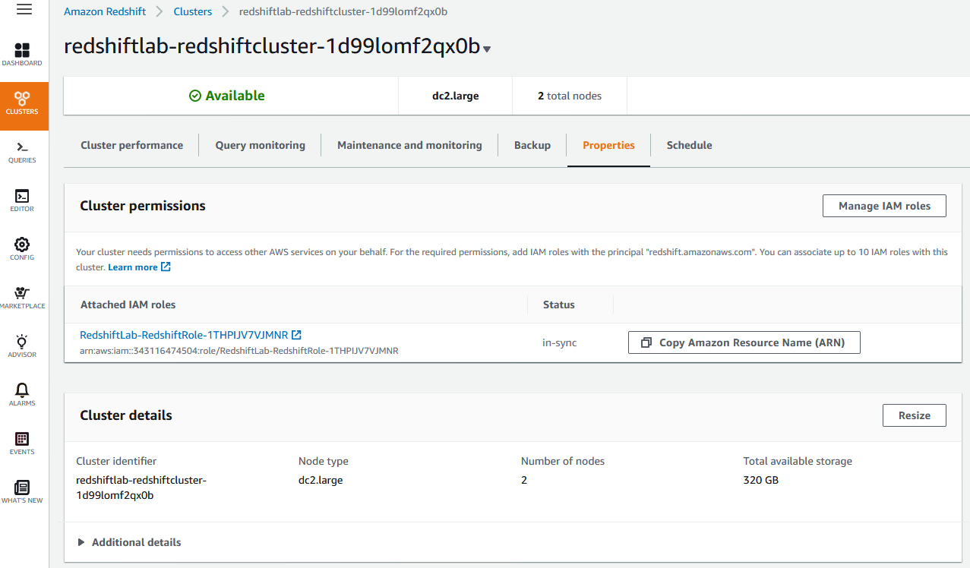

Click on the cluster and then **Properties** tab.

Under **Database configurations** click on the parameter group and review the WLM configuration.

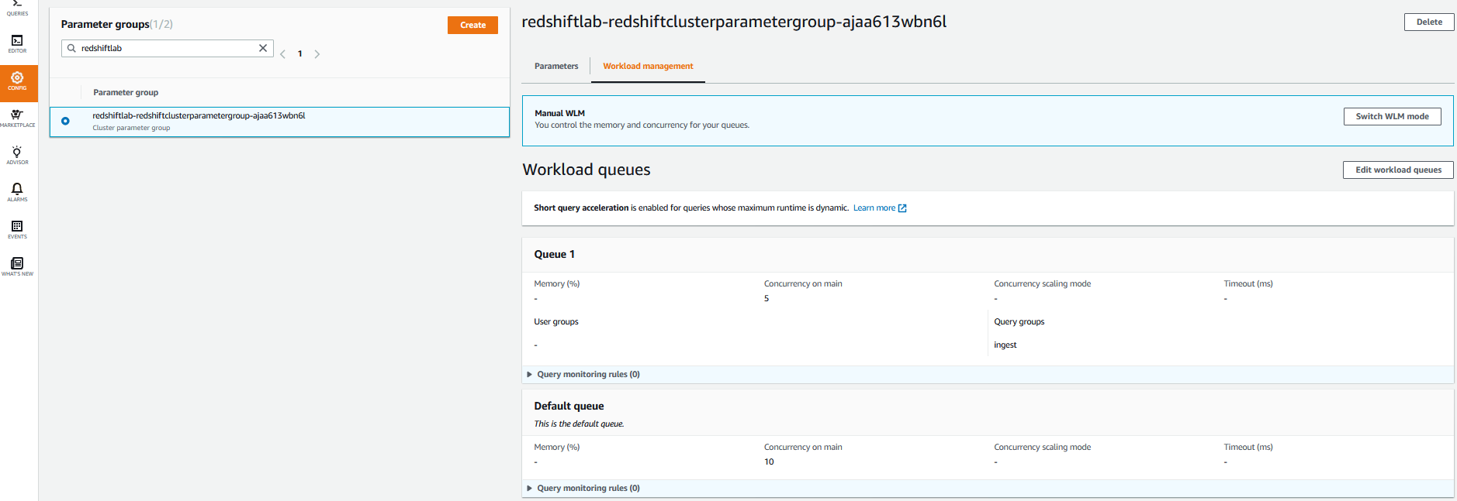

**Summary of the WLM:**

* Manual WLM with a total of 2 queues
* Queue 1 has concurrency of 5 and query group = “ingest”
* The 2nd queue is the Default queue with a concurrency of 10.

## Retrieve Redshift password

The login info for the Redshift cluster is to be stored in AWS service **Secrets Manager**.

Navigation: **Services > Secrets Manager**.

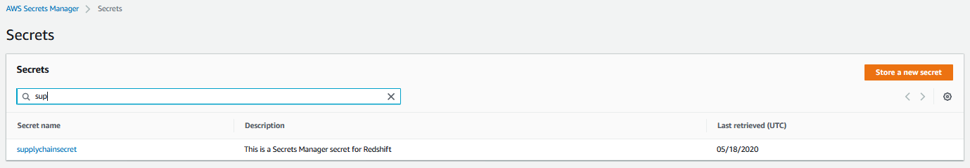

Click **supplychainsecret**

Click on **Retrieve the secret value**

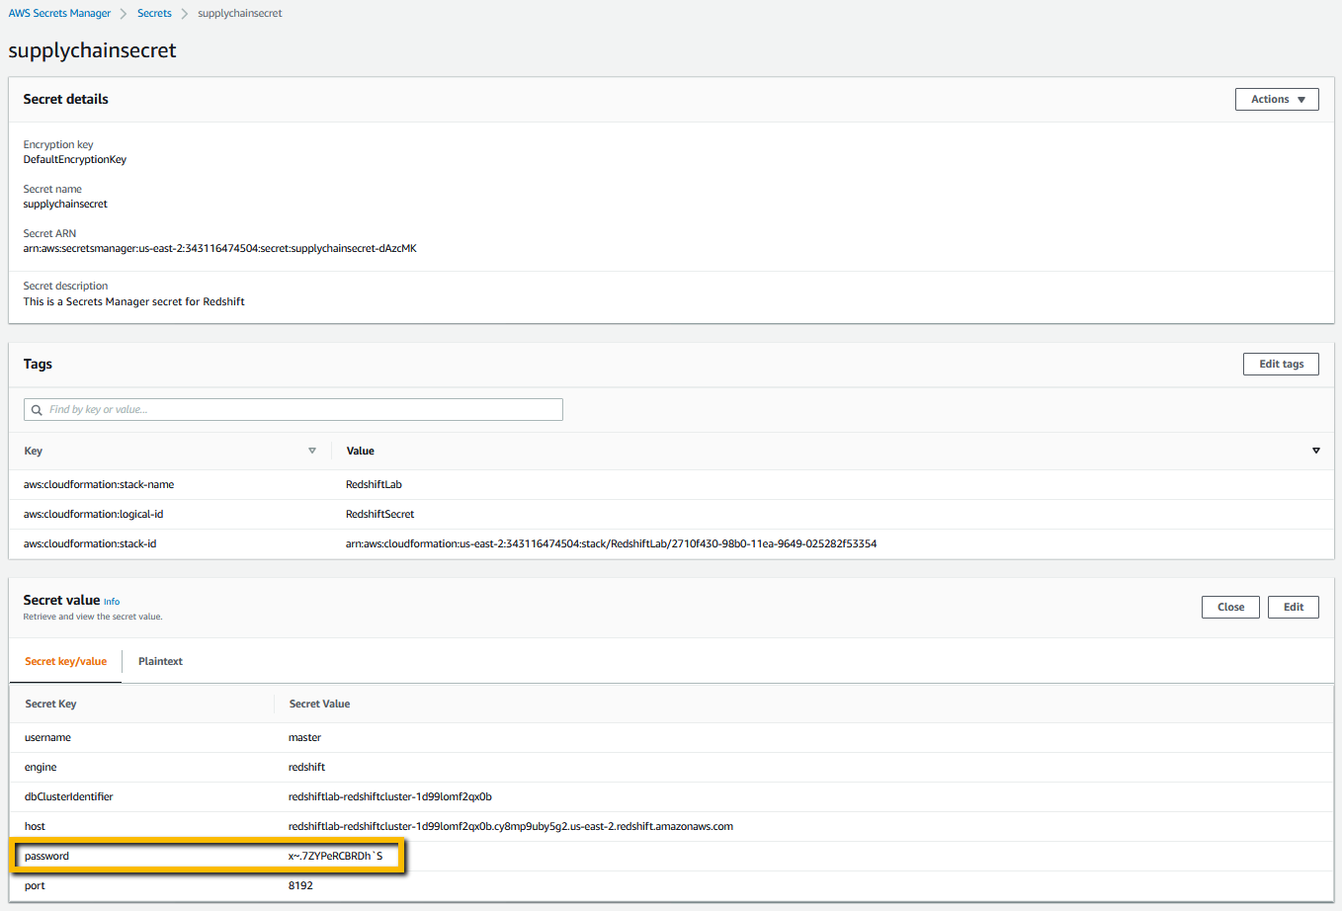

## Connect to the Redshift cluster

Navigate to **Services > Redshift**

Click on **Editor** from the left pane. In the **Connect to database** prompt enter the details for your cluster and connect to database.

* Database name: supplychain
* Database user: master
* Database password: (You should have retrieved from the Secrets Manager described under section Retrieve Redshift password)

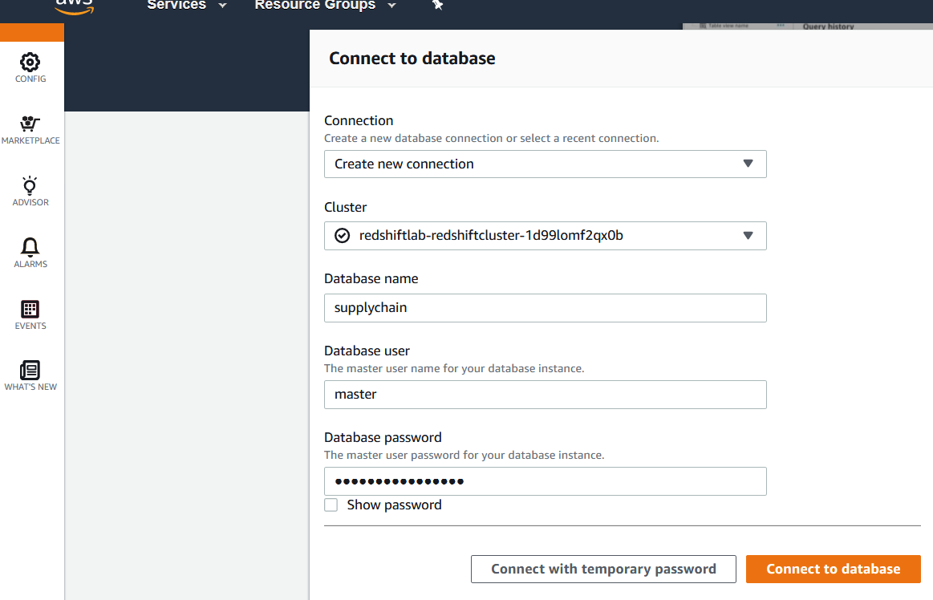

Under **Select schema** click on drop down. There will be only 4 schema at this point.

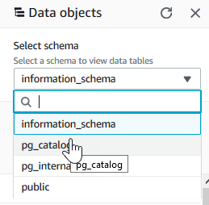

# **Create ELT pipeline:**

We will create Glue job as the building block for ELT pipeline. The pipeline will be created using State machine to orchestrate between jobs in an ELT flow.

Note: NO code writing is required. The necessary code is included in the lab package. However you can use this code to build your real world pipeline.

## Glue Job

Navigate to AWS Glue service by **Services > AWS Glue**

Click on **Databases > Connections**

A connection name “redshift-conn” should exist. Select the connection and **Action > Edit connection**

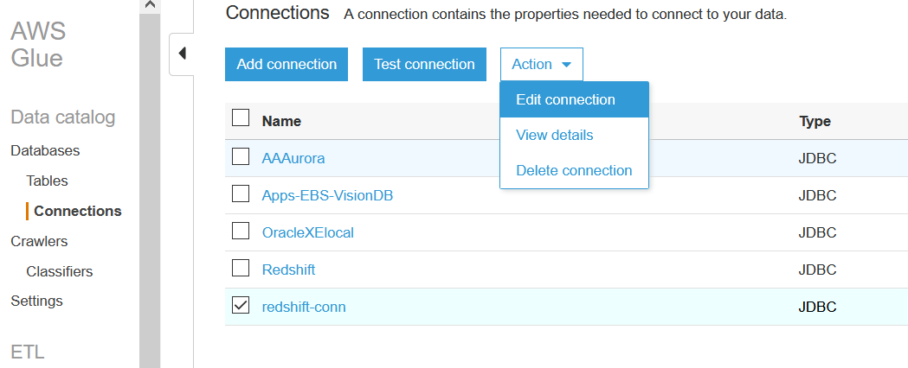

Click Next until you reach the **Set up access to your data store**. window.

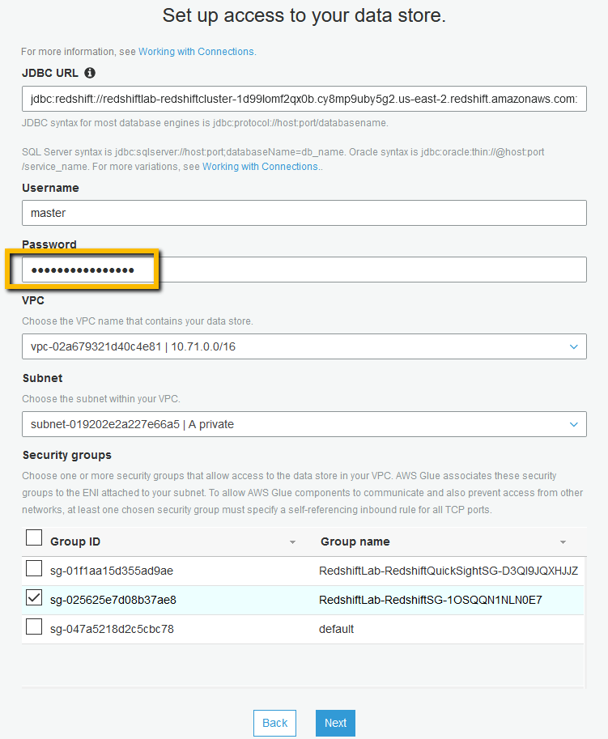

Here you need to enter the connection password. Find the Redshift password as described under section “Retrieve Redshift password”.

Click **Next** and

Click **Finish**.

Come back to the Glue 🡪 **connection** screen

if you are not already and select the “**redshift-conn**” connection and hit “Test connection”.

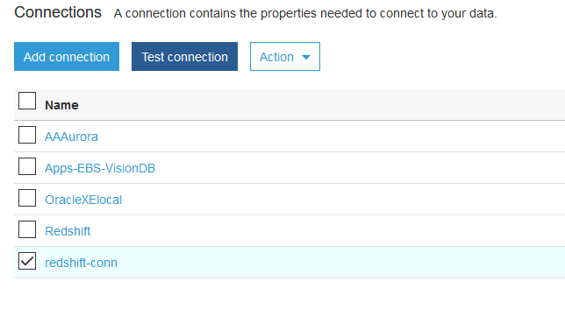

From the IAM Role dropdown select IAM role created by CloudFormation template at the beginning.

IAM role name will be like - **RedshiftLab-GlueExecutionrole-<randomstring>** and hit Test connection.

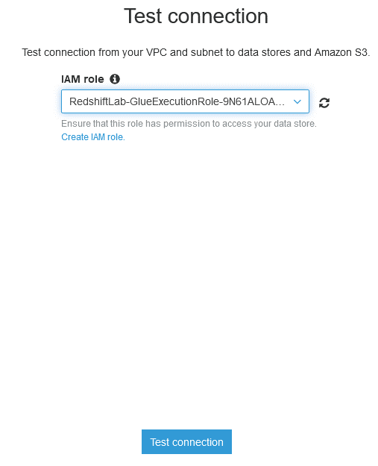

Note: It will take a couple of minutes to test the connection.

You will get a confirmation saying “**redshift-con** connected successfully to your instance”.

**Glue ETL Job**

Once connection is established you will update the Glue Job to include the connection information.

From the left pane **ETL > Jobs** Select the job“rs-query”and then **Action > Edit job.**

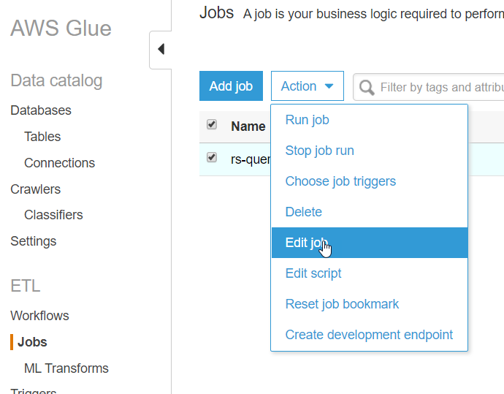

In this screen select the “**redshift-con**” connection from All connections so that it appears under Required connections. Hit save.

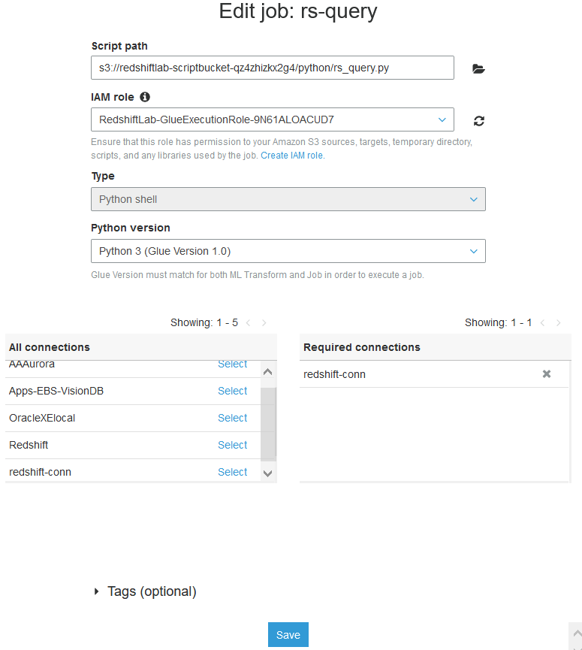

# **Redshift schema setup**

We will setup the schema and create the database tables from Redshift Editor.

Navigate **Services > Redshift**. From the left pane click **Editor**. If you have already connected to the editor in the section **Navigate to your Amazon Redshift cluster** then you will be automatically connected to the database. Otherwise follow the steps in the section **Navigate to your Amazon Redshift cluster**.

In the Query editor click on the “+” sign to open a new tab. Paste below scripts.

CREATE SCHEMA supplychainschema;

CREATE EXTERNAL SCHEMA spectrum_schema FROM DATA CATALOG database 'default' region '{<enter-aws-region>}' iam_role '{<enter ARN of IAM ROLE associated in Redshift>}';

CREATE TABLE supplychainschema.nyc_greentaxi(

vendorid varchar(10),

lpep_pickup_datetime timestamp,

lpep_dropoff_datetime timestamp,

store_and_fwd_flag char(1),

ratecodeid int,

pulocationid int,

dolocationid int,

passenger_count int,

trip_distance decimal(8,2),

fare_amount decimal(8,2),

extra decimal(8,2),

mta_tax decimal(8,2),

tip_amount decimal(8,2),

tolls_amount decimal(8,2),

ehail_fee varchar(100),

improvement_surcharge decimal(8,2),

total_amount decimal(8,2),

payment_type varchar(10),

trip_type varchar(10),

congestion_surcharge decimal(8,2))

;

You can find your IAM ARN by navigating to Redshift CLUSTERS > Properties tab

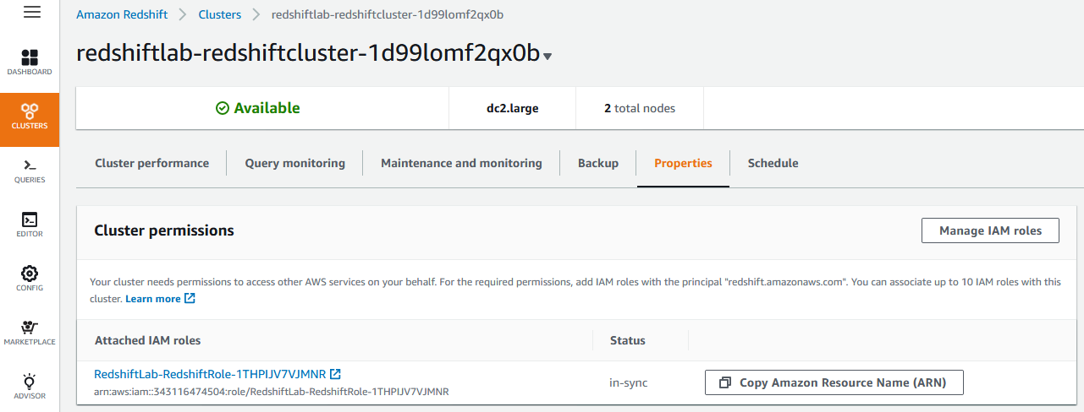

Update Screenshot

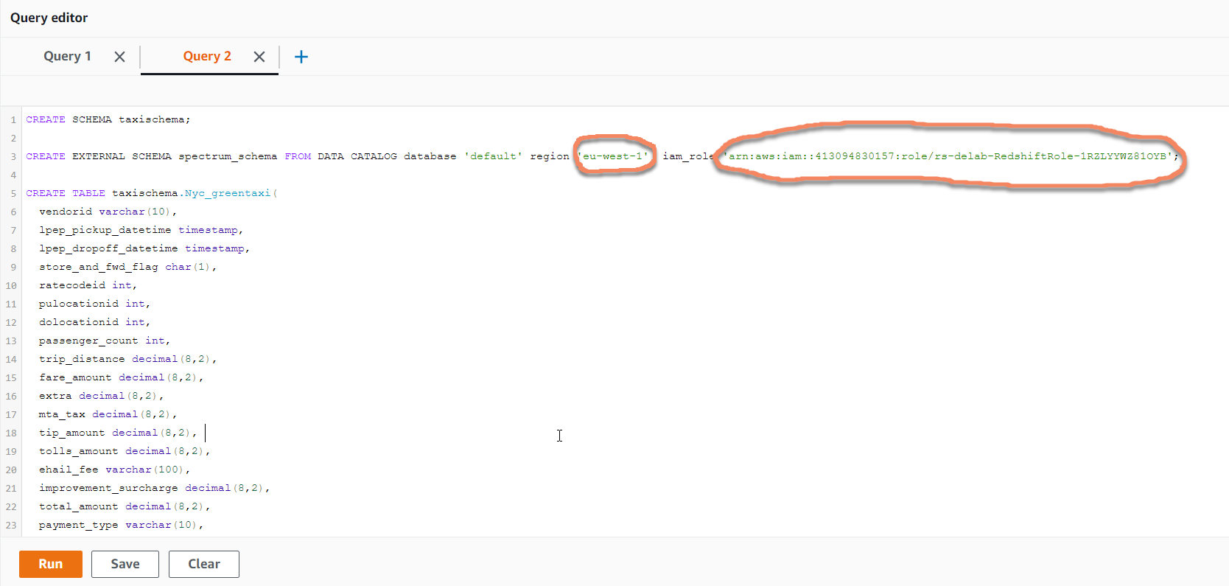

Execute each statement one after another by selecting the statement and hit Run.

Once the statements are executed check the schema that got created in Redshift.

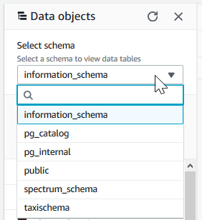

# ELT Execution

Now the State machine needs to be executed to orchestrate 1) ingestion into Redshift i.e **EL**(T) and 2) Unload the data into data lake i.e (EL)**T**

Navigate to **Step Functions** page and click on theState machineand hit Start execution. Leave the JSON input as is. Monitor the progress of the job under Visual workflow.

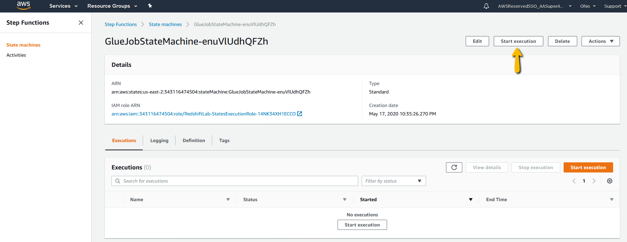

# Reporting

The above step brings us to for the first time to look at the data we just loaded.

Open **Quicksight** in AWS Console the Services options and then select the region as instructed by your instructor.

**Note**: If this is your first time in QuickSight you will need to sign up for Standard License. All you need is to provide a name of this QuickSight account and your email id.

Click on **New Dataset > Redshift (auto discovered)**.

In the next screen select the instance Id from the drop down and fill in the Username and password for the Redshift cluster.

Click on **Validated** button to make sure connection is successful.

Hit **Create data source.**

Update Screenshot

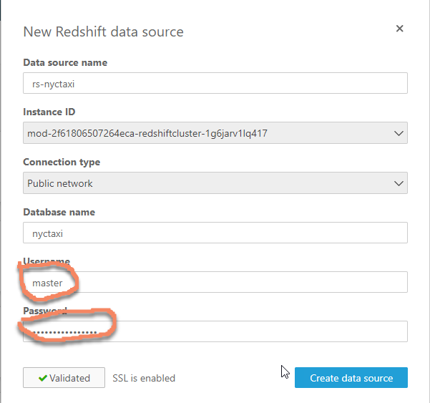

In the next screen select “supplychainschema” schema and the “nyc_greentaxi” table.

Update Screenshot

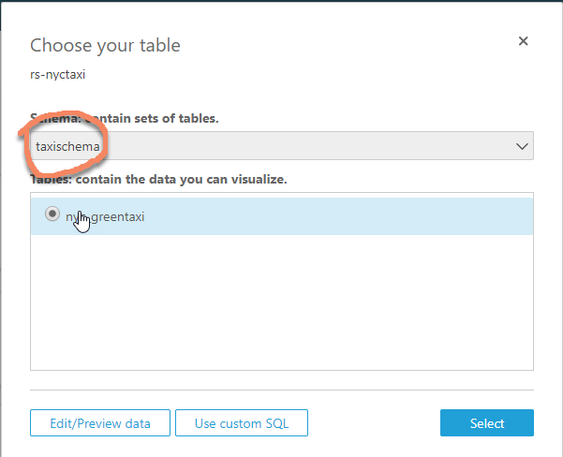

In the following screens select **Preview data > SPICE** as Data source and then **Save & visualize**.

Let’s do some visualization of the data in Redshift.

**Viz# 1- Trip count over time**

From the **SPICE nyc_greentaxi** Data set pane click on fields *lpep_pickup_datetime* and *trip_type*. Adjust the graph by scrolling the bottom bar towards right.

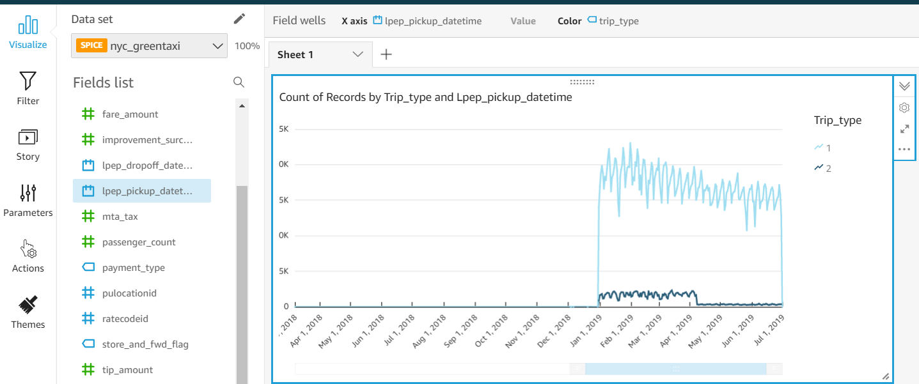

**Viz# 2- Histogram on Trip distance**

To add another graph click + Add button on top left corner of the screen and select “**Add visual**”.

In order to plot histogram you need to create a calculated field. Click on + Add button and select “**Add calculated field**”.

Provide field name *Trip_dist_buckets* and enter the below formula and hit Create.

ifelse({trip_distance} <= 5,'0-5',{trip_distance} > 5 and {trip_distance} <= 10,'5-10',{trip_distance} > 10 and {trip_distance} < 30,'10-30','> 30')

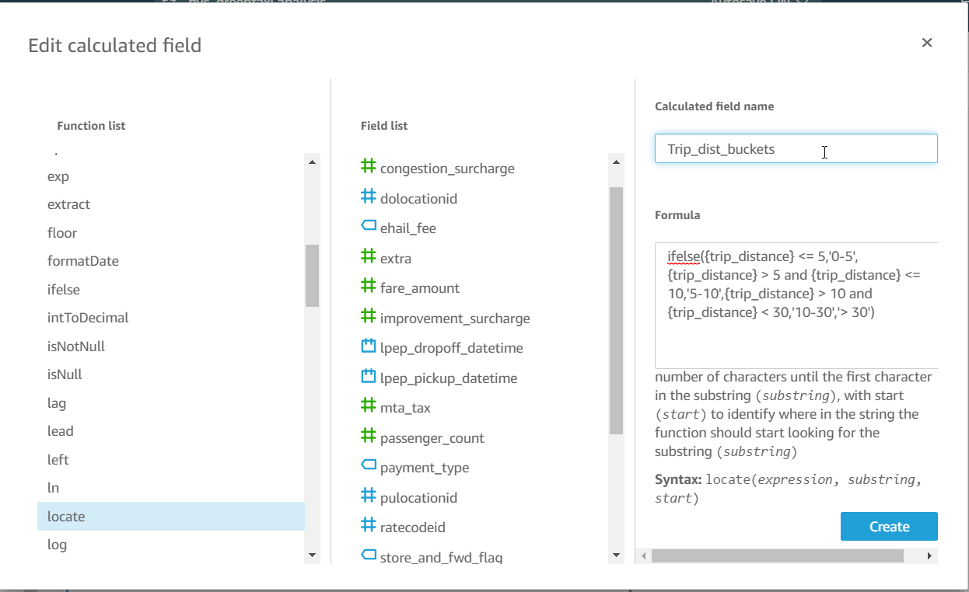

Next select visual type “**Clustered bar combo chart:**” from the Visual types pane.

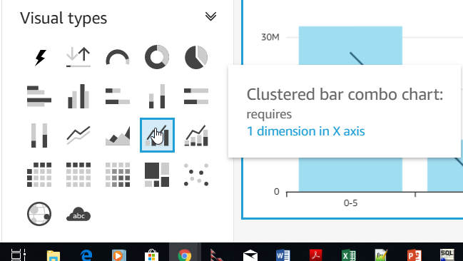

From the data set pane click on *Trip_dist_buckets*, *total_amount* and *lpep_pickup_datetime.* Then click on the field well on the top.



Drag *lpep_pickup_datetime* into the Lines well*.*

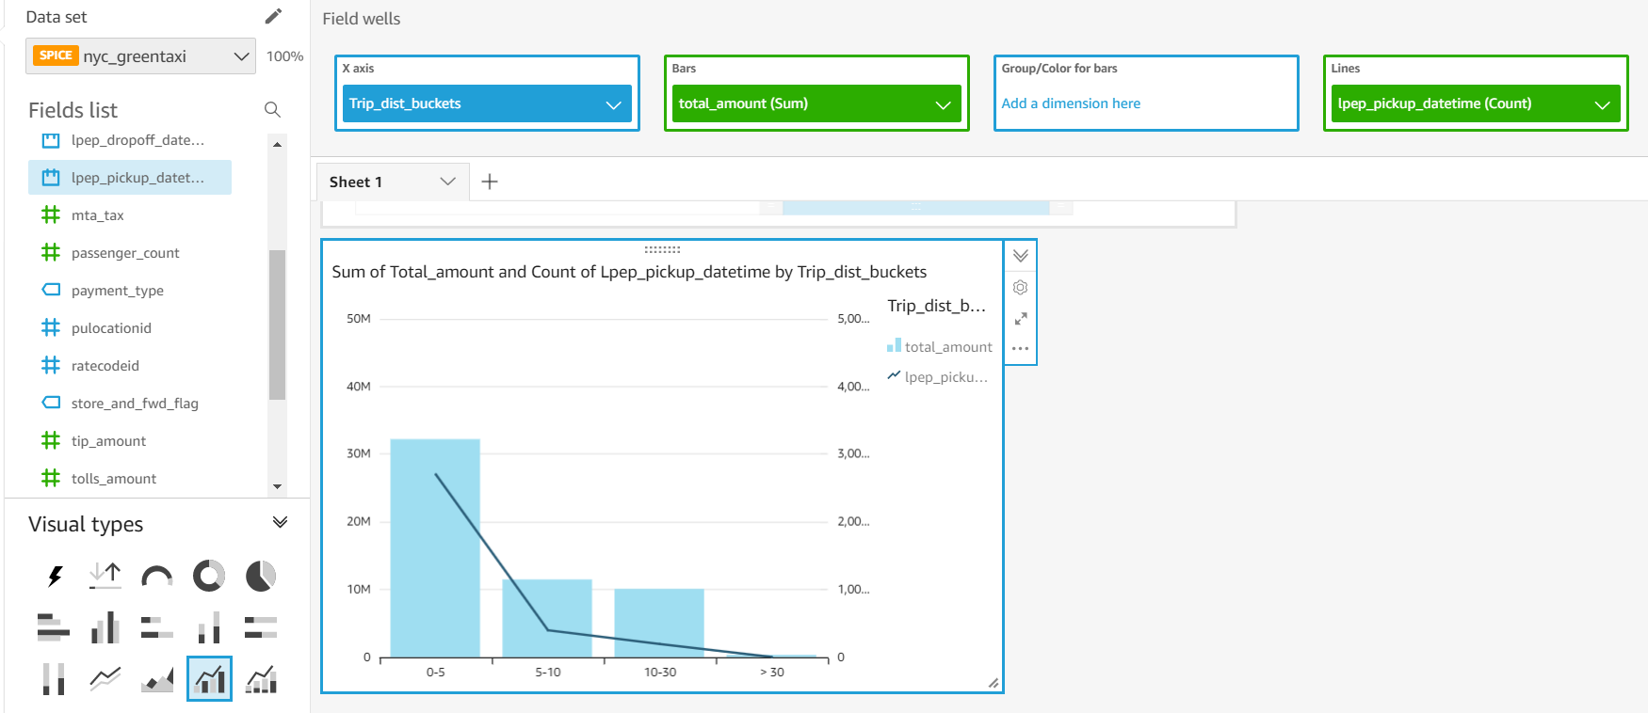

# **Build on the data lake**

The above visualization provides very little insight on some of the dimensions of the data for example *trip_type* and *payment_type* are encoded as integer value.

Next we want to create transformation and visualize the transformed data using QuickSight.

You will first create a crawler to register the Parquet data unloaded from Redshift, into Glue catalog.

**AWS Glue> Crawlers > Add crawler**. Give a crawler name and hit next couple of times until you reach **Choose a data store**

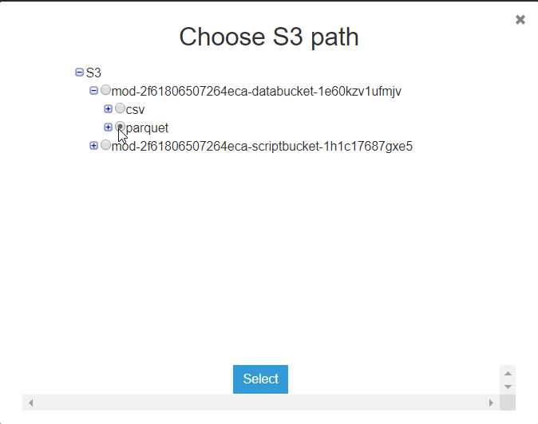

Include path add the location of the parquet folder. It will look like below-

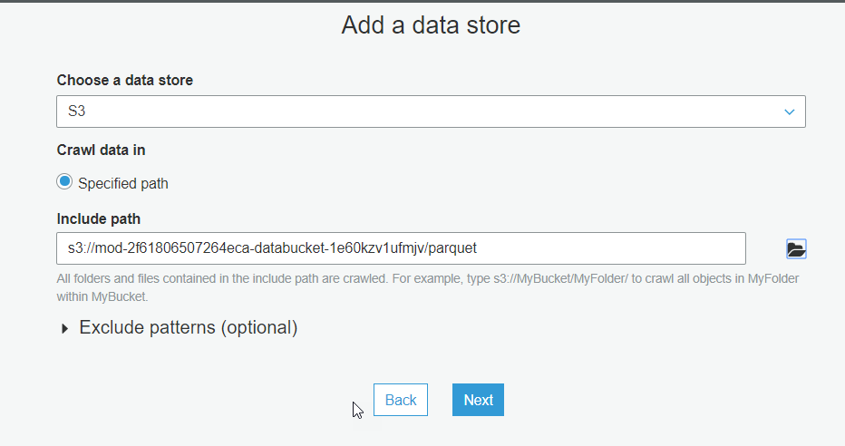

Hit next couple of times. Choose the IAM role that does NOT say “TeamRole”.

After next few screens click on Add database and give the name “**default**” and enter “**nyctaxi_**” as Prefix added to tables.

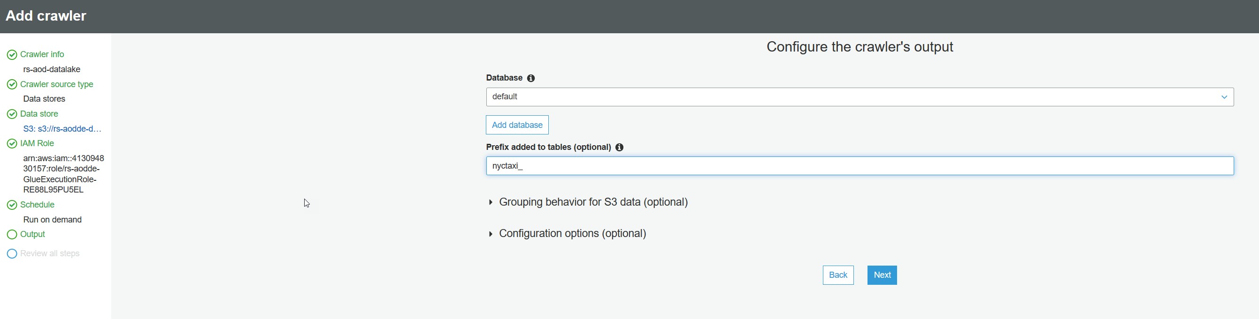

Hit Finish and click on **Run it now**.

Once finished the new table **nyctaxi_parquet** will show up under **Databases > Tables**.

We go back to QuickSight creating a new Dataset.

Create a **New Redshift data source**.

Select the spectrum_schema and nyctaxi_parquet table and then **Edit/ Preview data**

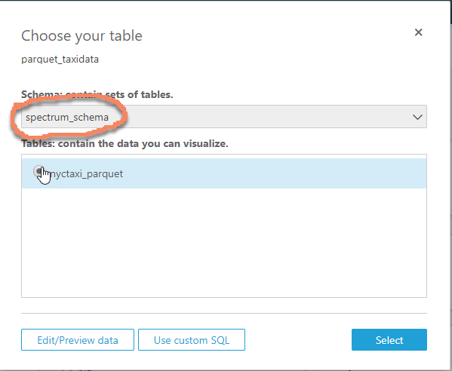

Select **SPICE** and then **Save and visualize**.

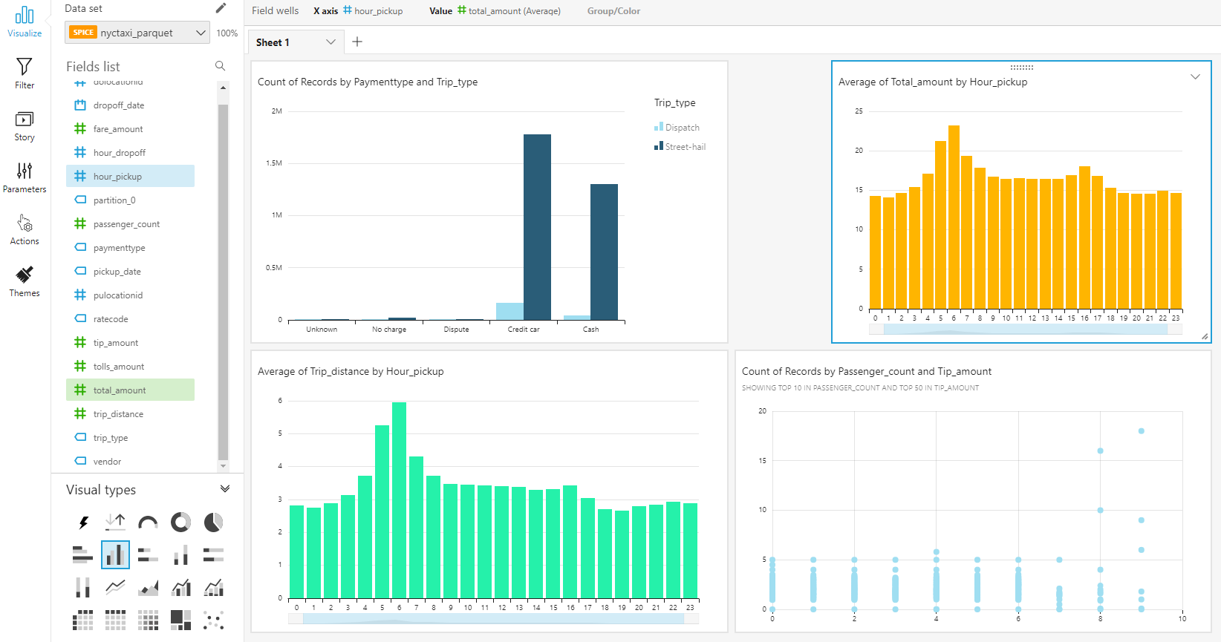

This brings us to the end of the lab.

# Delete AWS resources from Cloud formation console.

Select the stack you created at the begin and click DELETE Stack.

Please fill in the survey at the end of this lab.